What causes dystonia?
For many people with dystonia no cause is found. When no cause is found, it is generally accepted the cause is related to a problem with the functioning and connections of various areas of the brain including the basal ganglia and the cerebellum that are involved in movement. For some people dystonia may be the result of certain medications, trauma or other neurological conditions such as stroke or infection. However, a genetic abnormality has been found in certain types of dystonia.
How is dystonia inherited?
Genetics, the study of genes, is very complicated. Except in very rare cases, a baby is born with 46 chromosomes, 23 inherited from each parent. 44 of these are called autosomes or non-sex chromosomes (apply to either sex) and 2 are sex chromosomes. Of these sex chromosomes the mother provides one X chromosome and the father either another X chromosome for a female child (XX) or a Y chromosome for a male child (XY).

Chromosomes are thread-like strands, arranged in pairs that are composed mainly of DNA (deoxyribonucleic acid) and contain the person’s genetic information. They are found in the nucleus (central part) of almost every cell in the body. There are around 24,000 genes and the combination of the genes inherited from the parents make up the recipe for each person’s genetic make-up, such as hair and eye colour, facial features etc.
Each gene is responsible for a particular protein. Proteins have an important function in our biology so when a gene is changed as in a gene mutation, the protein for that gene cannot function normally and this can result in a disease process such as dystonia.
The mutations (changes) in the genes discovered so far in dystonia are mostly dominant. Dominant genes affect how the child develops. This means that only one parent needs to have the mutated gene for children to inherit it and each child has a 50% chance of inheriting that gene. However, in dystonia not all people with the gene mutation will have symptoms of dystonia or they may have very mild symptoms – this is called reduced penetrance. For instance the child or adolescent with the DYT1 gene has only a 30-40% chance of having many of the symptoms of generalised dystonia (expressing the gene).
If the gene for dystonia is recessive, that is it is not a gene that is involved in the development of the child, it will not be passed on unless the other parent also has this recessive gene. If this is the case the dystonia will be passed on to the child. One of the genes responsible in some cases for dopa-responsive dystonia (DYT5b) is a recessive gene.
What types of dystonia have a genetic base?
At present around 25 gene mutations have been found in various forms of dystonia. However, it is important to understand that this represents a very small proportion of people with dystonia. Included in these is, as discussed, early-onset generalised dystonia in children and adolescents who may carry the DYT 1 gene. This was the first gene isolated for dystonia. Among other genes found in dystonia are dopa-responsive dystonia, DYT 5a / 5b / 14, myoclonus dystonia DYT 11 and segmental dystonia with spasmodic dysphonia (laryngeal dystonia), DYT 6 .
It is also important to realise that just as some people or children who have the gene mutation may not have any symptoms, people or children may have the above conditions but do not carry the known gene(s). This may be because the gene that is responsible for their dystonia has not yet been found.
Why do we need to know if the dystonia has a genetic basis?
Understanding the genetics of dystonia allows specialist neurologists and geneticists to make
better diagnoses for people with dystonia and be able to suggest the best available treatment. This in turn will eventuate in more targeted treatments as the biology of dystonia is better understood.
What do I do to find out if my children will inherit my dystonia?
First of all speak to your specialist neurologist who has a better understanding of the biology of dystonia and who can refer you and/or your family to see a geneticist if there is a likelihood your dystonia has a genetic basis, or reassure you that your type of dystonia is not likely to be genetic. Where there is a possible genetic cause, the specialist will discuss the possibility of genetic counselling. This will help you understand the up to date information on your dystonia so that you can make decisions on yours and your family’s future.

Help us help people with dystonia by becoming a member, assisting
with fundraising or joining/starting up a support group.
Go to our website or contact the association directly for information.

Dystonia Network of Australia Inc. (DNA)
Registered Charity ABN: 66 348 949 649
9 Denman Parade Leura NSW 2780
Tel/Fax: (02) 4784 3368
dystonianetwork@gmail.com www.dystonianetworkofaustralia.org

Disclaimer
The information contained in this leaflet is of a general nature only. Please consult a Movement Disorder Specialist or Neurologist if you have specific questions regarding your condition.
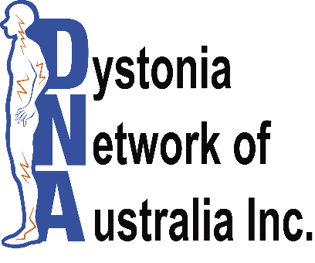

Genetics in Dystonia

