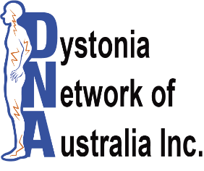
Photo / Video / Interview Consent Form

I _________________________________________ (full name) give my permission to Dystonia
Network of Australia Inc. (DNA Inc.) to:
a. Take a photo/ Video of me in an individual or group photograph YES NO
b. Interview me for publication through the media listed below for a broadcast YES NO
In providing this permission, I understand that this image may be used by Dystonia Network of Australia Inc. for one or all of the following:
1. To accompany editorial to local news publications OR
2. Within print, web-based or multi-media marketing materials produced by Dystonia Network
of Australia Inc. such as newsletters, banners, brochures, posters or videos

If there is any specific medium or type of use that you object to your image being used by Dystonia Network of Australia Inc. please state below
__________________________________________________________________
Dystonia Network of Australia Inc. will keep your image in a secure location for a period of two years and seek further permission from you for continued use if required. Your information will not be passed on to any other organisation or individual for their use.
Name: __________________________________________
Address: __________________________________________
__________________________________________
Phone: ___________________________
Signature: ___________________________ Date: / /

