Date 02/06/2016

Dear Sir or Madam,

We are writing to invite you to participate in a study entitled ‘The effects of transcranial direct current stimulation on quality of life in people with cervical dystonia’. You are receiving this letter because you are on the database of the Dystonia Network of Australia Inc. or you have already participated in a study in cervical dystonia conducted by Dr Bradnam and have consented to be approached for future studies.

This study is being conducted by Professor Lynley Bradnam and Dr Alana McCambridge from the Clinical Neurostimulation Laboratory, Discipline of Physiotherapy at University of Technology Sydney (UTS), Professor Teresa Kimberley, University of Minnesota, USA and Professor Sheila Lennon, Professor of Physiotherapy at Flinders University.

The aim of this study is to assess the effects of five sessions of transcranial direct current stimulation, a painless form of non-invasive brain stimulation on your quality of life. Emerging studies using this type of non-invasive brain stimulation to stimulate particular areas of the brain have illustrated the potential to have a meaningful impact on quality of life for people with cervical dystonia.

You would be required to attend the Clinical Neurostimulation Laboratory at UTS in Sydney for five intervention sessions over the course of 5 days and then repeat this again in approximately 12 weeks later (i.e., 2 x 5-day treatment periods). The first session would preferably be scheduled as close as possible to 4 weeks after your botulinum toxin injections if you are receiving these as a treatment. At the fisrt and last assessment sessions, neurophysiological measures will be taken using transcranial magnetic stimulation. You will be asked to complete questionnaires regarding pain, the severity of your dystonia and how it affects your life at each assessment point, as well as 1 week after the end of the 5-day period and 7 weeks after the end of the 5-day period via questionnaires sent via email or post.

We cannot pay you for your time but we can reimburse travel expenses via a petrol voucher.

If you are interested in learning more about the study or participating in it, please contact Alana McCambridge by email ([alana.mccambridge@uts.edu.au](mailto:alana.mccambridge@uts.edu.au)) or phone (ph: 9514 7222) for more information. We look forward to hearing from you.

Kind regards,

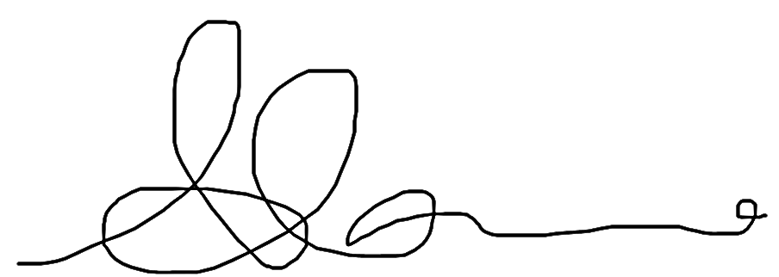

Professor Lynley Bradnam Dr Alana McCambridge

Head of Discipline Physiotherapy Postdoctoral research fellow

Graduate School of Health Graduate School of Health

University of Technology Sydney University of Technology Sydney