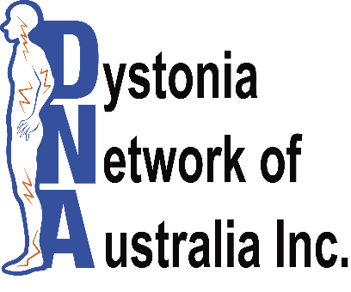
You are invited to attend the

Inaugural Dystonia Seminar
for health professionals & people with dystonia
Speakers & Topics:
Professor M. de Konig-Tijessen (Netherlands) – Keynote Speaker on Dystonia Net (Cervical Dystonia) and the Approach in Children and Young Adults with Dystonia
Dr S. Tisch, Neurologist – Spasmodic Dysphonia & Tremor
Dr. B. Jonker, Neurosurgeon – Deep Brain Stimulation
Professor L. Bradnam & M. Boyce, Physiotherapists – Physiotherapy in Dystonia
H. Brake, Manager Speech Pathology Unit - Speech & Swallowing
Dr. F. Chang, Neurologist - Dystonia Coalition
A/Professor V. Fung, Neurologist - Q & A Dystonia
When: Friday 14th August 2015 from 9.30 am – 3.00 pm
Where: Garvan Institute of Medical Research, The Auditorium,

Level 1, 384 Victoria St. Darlinghurst, NSW 2010
(Entry via Burton Street, Cnr of Burton and West Street)
Cost: $50.00: Morning tea & lunch provided
“Dystonia - muscles behaving badly” - Lily, aged 7

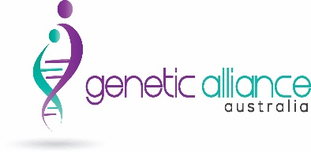
Please visit www.dystonia.org.au or email info@dystonia.org.au for more
information
Kindly sponsored by

Registration is limited. Lunch and morning tea are provided. (Please indicate below if you have any special dietary requirements). For catering purposes, please RVSP by 3rd August 2015, to Genetic Alliance Australia, C-/ Garvan Institute of Medical Research, Level 6, 384 Victoria St, Darlinghurst NSW 2010.

NAME(S): ___________________________________________________________________________________________________________

ADDRESS: ___________________________________________________________________PHONE: _________________________________

EMAIL: _______________________________________________ SPECIAL DIETARY REQUIREMENTS: ________________________________

AREA OF INTEREST____________________________________________________
Payment to Genetic Alliance Australia
Cheque – Please make payable to Genetic Alliance Australia and mail to The Treasurer, Genetic Alliance Australia Inc. C-/ The Garvan Institute of Medical Research, Level 6 364 Victoria St. Darlinghurst NSW 2010.
Paypal – Using our email info@geneticalliance.org.au Please make a payment of ‘Goods and Services,’ with the description ‘Dystonia’
EFTPOS – BSB 032 131, a/c 117037 Name: Genetic Alliance Australia
State payment details as follows: SURNAME, Initials, Dystonia DNA Inc. Registered Charity ABN: 66 348 949 649 CFN /23669

